QUIZ GAME

Project submitted to the

### SRM University – AP, Andhra Pradesh

### for the partial fulfillment of the requirements to award the degree of

**Bachelor of Technology**

In

**Computer Science and Engineering**

**School of Engineering and Sciences**

Submitted by

Candidate Name

Sahithya Chilukuri |AP21110010181

Under the Guidance of

**(POONAM YADAV)**

**SRM University–AP**

**Neerukonda, Mangalagiri, Guntur**

**Andhra Pradesh – 522 240**

**[December, 2022]**

**Certificate**

**Date:** 13-Dec-22

This is to certify that the work present in this Project entitled “**QUIZ GAME**” has been carried out by **[ CHILUKURI SAHITHYA ]** under my/our supervision. The work is genuine, original, and suitable for submission to the SRM University – AP for the award of Bachelor of Technology/Master of Technology in **School of Engineering and Sciences**.

**Supervisor**

(Signature)

Prof. / Dr.Poonam yadav

# Certificate

**Date:** 13-Dec-22

This is to certify that the work present in this Project entitled “**QUIZ GAME**” has been carried out by **[ Y. NARASIMHA RAO ]** under my/our supervision. The work is genuine, original, and suitable for submission to the SRM University – AP for the award of Bachelor of Technology/Master of Technology in **School of Engineering and Sciences**.

**Supervisor**

(Signature)

Prof. / Dr.Poonam yadav

**Certificate**

**Date:** 13-Dec-22

This is to certify that the work present in this Project entitled “**QUIZ GAME**” has been carried out by **[ GOPAVARAPU SIVAMANI ]** under my/our supervision. The work is genuine, original, and suitable for submission to the SRM University – AP for the award of Bachelor of Technology/Master of Technology in **School of Engineering and Sciences**.

**Supervisor**

(Signature)

Prof. / Dr.Poonam yadav

# Acknowledgements

I would like to thank my teacher Poonam Yadav who gave me the opportunity to work on this project. I got to learn a lot from this project about the function and various module.I am very grateful to her for her support and guidance in completing this project. Finally, I want to thank all my teammates as well for being part of the team and for helping me complete this project.

Group 10

CSE-C

# Table of Contents

Certificate …………………………………………………………………… 3

Acknowledgements ………………………………………………………… 8

Table of Contents …………………………………………………………… 10

Abstract ……………………………………………………………………... 12

Statement of Contributions ……………………………………………………... 14

1. Introduction ……………………………………………………………. 16

2. Methodology …………………………………………………………… 18

2.1 Design …………………………………………………………………….. 18

2.2 Implementation ……………………………………………………. 18

3. Results ……………………………………………………………………….... 25

4. Concluding Remarks ….;……………………………………………… 29

# Abstract

Quiz Game is user friendly and reduces the manual effort.In past days Quiz was conducted manually but nowadays by using technology we are able to generate automatic scores. In this project we have developed a Quiz Game.The concept of quizzes is very popular among educated circles as well as in some entertainment shows.Quizzes contribute to growth of the knowledge of an individual and they are a popular source of entertainment.

This quiz game will be user friendly with which user can gain some knowledge and can also get entertainment.This game has multiple questions and it also calculates the scores of each correct answer.It is good for students of every age group it helps in increasing General knowledge about world,Sports,Computer etc.No need to register, simply give your user name and you can login with the same user name.It helps user to increase his/her knowledge. As a part of Internal Assessments many colleges have been conducting Quizzes.

# Statement of Contributions:

D. Prasanna Kumar- Implementation and presentation

Ch. Sahithya- Implementation and report

Y. Narasimha Rao - coding and analysis

G. Sivamani- coding and report

# 1) Introduction:

The quiz games can be conducted for different age groups and over varying cultures Quizzes improve or expand one’s knowledge of things, either general or in specific areas Quizzes are designed to promote, a fun way to study and in the process help improve one’s general knowledge. And mainly our aim is to develop and conduct Online quizzes which makes people think in a more technical way.

Quiz game is accessed by entering your name which is added to the records. Before the start of the quiz,The rules and regulations will be displayed .Our quiz game will offer the player questions to which the player must respond with the answer. Each question will have four choices, in which the player should choose the correct choice.

If the player does not correctly answer the question then the player will earn no points and the correct answer is printed. However, if the player correctly answers the question, he will get a score according to his performance. The total score is displayed, along with the score we also display the correct options and options entered by the player. If the player wants to skip the current question, the player should enter “skip” and if the player wants to submit the test he should enter “submit”.Finally in this project we store the previous records so we can see the previous data.

# 2) Methodology

## 2.1 DESIGN:

This project has been designed majorly with the help of function concept and the OS module which is available in python.

1. The OS module is used in this project. The system() method of the OSmodule with the string cls or clear as a parameter is used to clear the screen in windows and macOS/Linux, respectively.
2. Many functions are used to do specific tasks to run the program.

### 

**2.2 Implementation:**

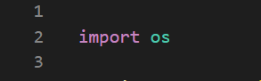

In this project we import the OS module into the code. From this module we will use the system() method to clear the screen. By adding the line “os.system(‘cls’)”.

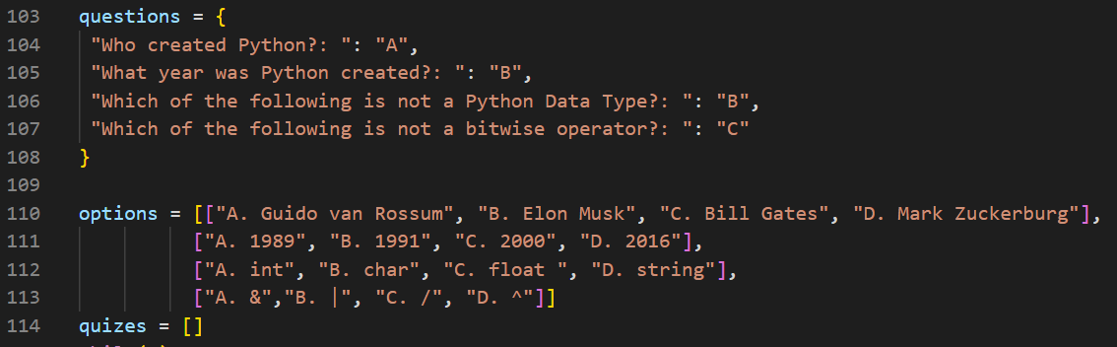

Here we used the dictionary concept. We created a dictionary named questions which is used to store the questions of the quiz. We know that every element in the dictionary has a certain key value. In this dictionary, key value is the correct option for that question.

One more concept we used in this project is lists. We created a list named as options and used it for the options of the above question. Here we again created another list inside of the options list. In this list first we will have 4 elements since the number of questions are four and for each question we are having 4 options so we used the list again here.Each element in options list is in list form.

One more list we added here is to store the results of the player. You will get to know more clearly about this later .

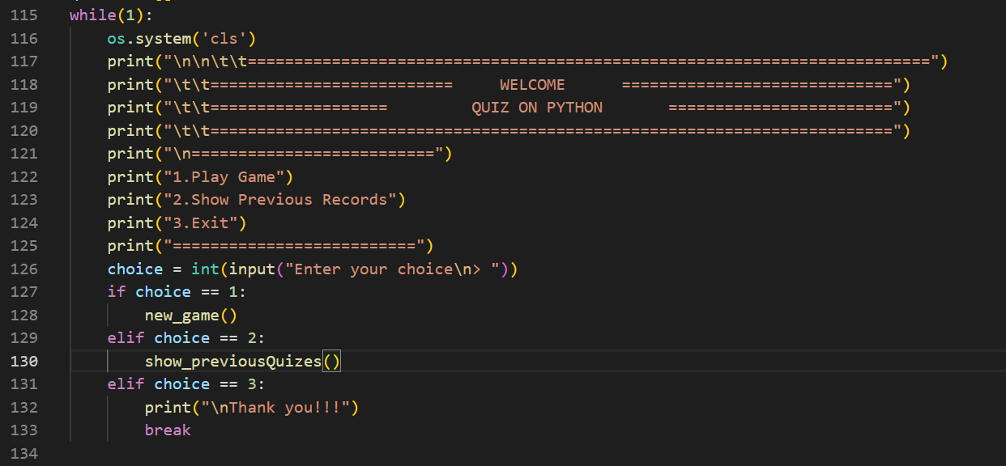

This part is the starting point where the main execution begins. Before printing anything it will clear the screen and the execution will continue. We should enter any choice from the display options.

If choice is one, then new_game() will be called and execute the statement. If choice is two, then show_previousQuizes() will be called and execute the statement. If the choice is three, it prints “Thank you!!!” and exits.

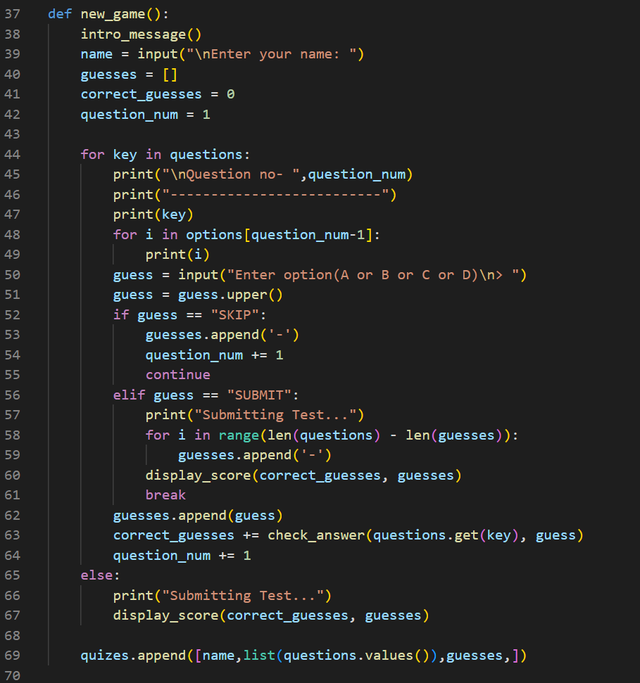

First the intro_message() is called,Player should enter the name. Now guesses is a list which is used to store the answer entered by the player .correct_guesses is a variable which is initialized to 0.If a player enters the correct answer then correct_guesses will be incremented and question_num is another variable which is initialized to 1.

Now the question is printed from the dictionary using for loop.Using for loop options printed from the list named options,the player should enter the option(converted into upper cases).

If the entered option is “SKIP” then “-”(blank) is added into the guesses .Then question_num is incremented and continues( it skips the rest of the statement and goes to the next iteration).

If the entered option is “SUBMIT” then , its print the “Submitting Test…”.Now we want to add “-” into guesses for remaining element ,so we find the number of times we want to add using the formula “**len(questions) - len(guesses)**”.Using for loop we will add “-” to remaining guesses.The display_score() function will then be called, exiting the for-else loop and storing the data before entering the while loop.

If the enter option is not “SKIP” and “SUBMIT” then the entered option is added into the guesses list,then it checks if the answer is correct or not by calling function check_answer. Function returns a value and it is added to correct_guesses,then question_num is incremented.

The display_score() function is called if either all questions have been answered or the for loop does not break in the middle. The name, the list of entered responses, and the correct answers are then added to the quizes list.

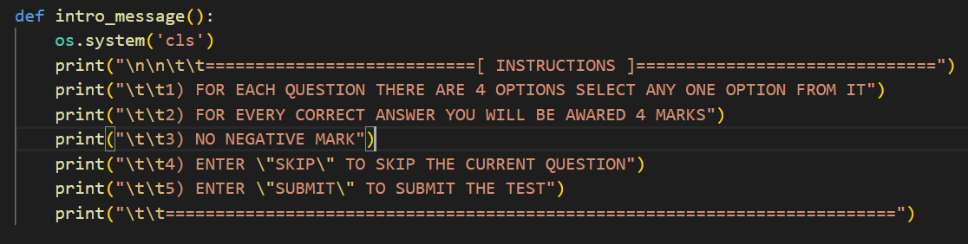

The screen is clean and the INSTRUCTIONS are printed there so that the player can understand the guidelines and perform well on the quiz.

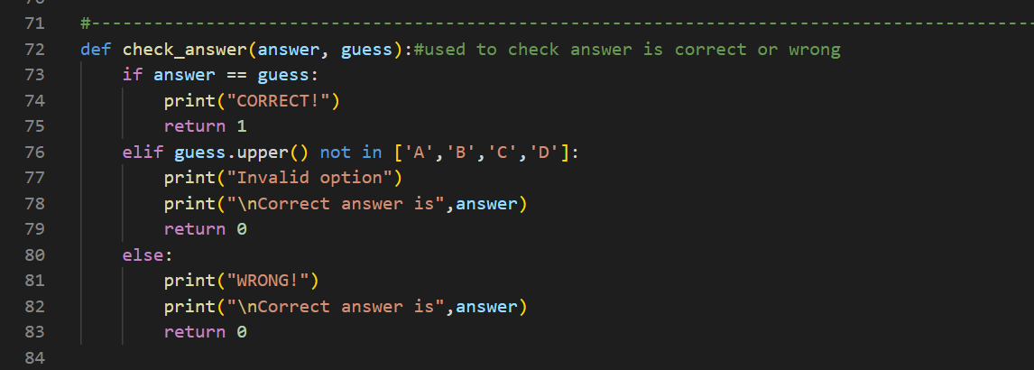

check_answer() function is used to find if the entered answer is correct or not.If entered guess == answer then prints “CORRECT!” and returns 1. If the entered guess is not from “A or B or C or D “ then it prints “Invalid option” and prints the correct answer,then returns 0. If the above two conditions fail then prints “WRONG!” and then prints correct answer & return 0.

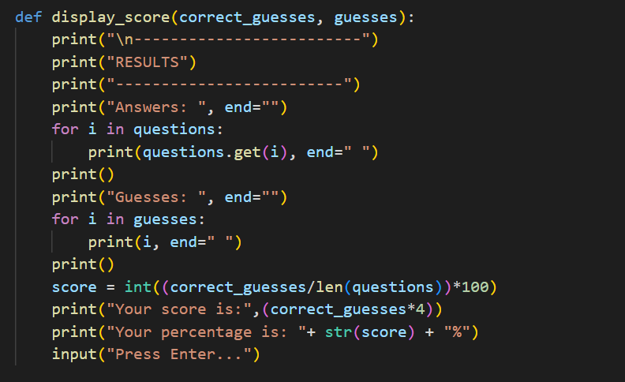

This function is used to display scores, entered guesses and the correct answers. It calculates the percentage and displays . At the end, we should press enter then it will enter into the while loop.

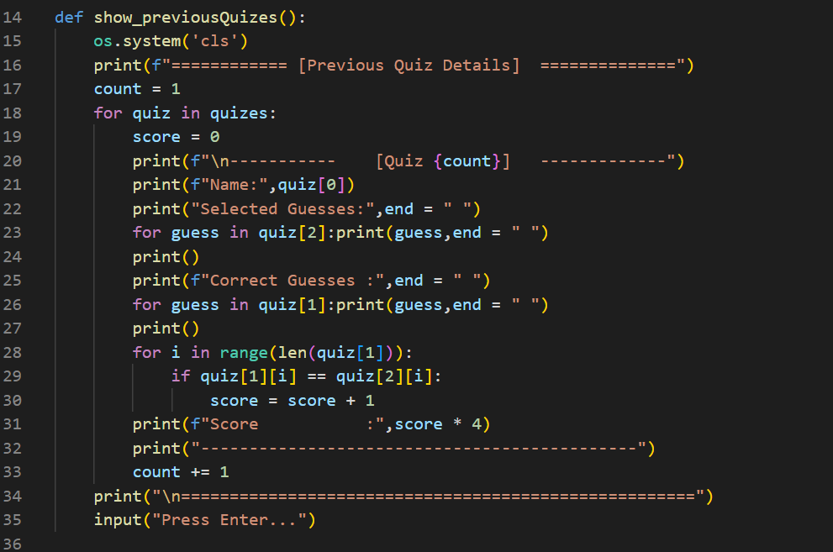

This function is used to print the previous data. In the new_game() function at last we created a list named as quizzes. In that list we add elements for each element we again created a list having names,entered guesses , and correct answers. After comparing the guesses entered and the correct responses, the score is increased to 1 (quiz[1][i] == quiz[2][i]).To print the score we have to multiply the score with 4.

**3) RESULTS**

**OUTPUT:**

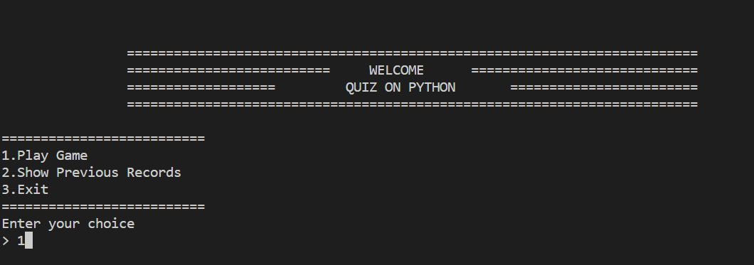

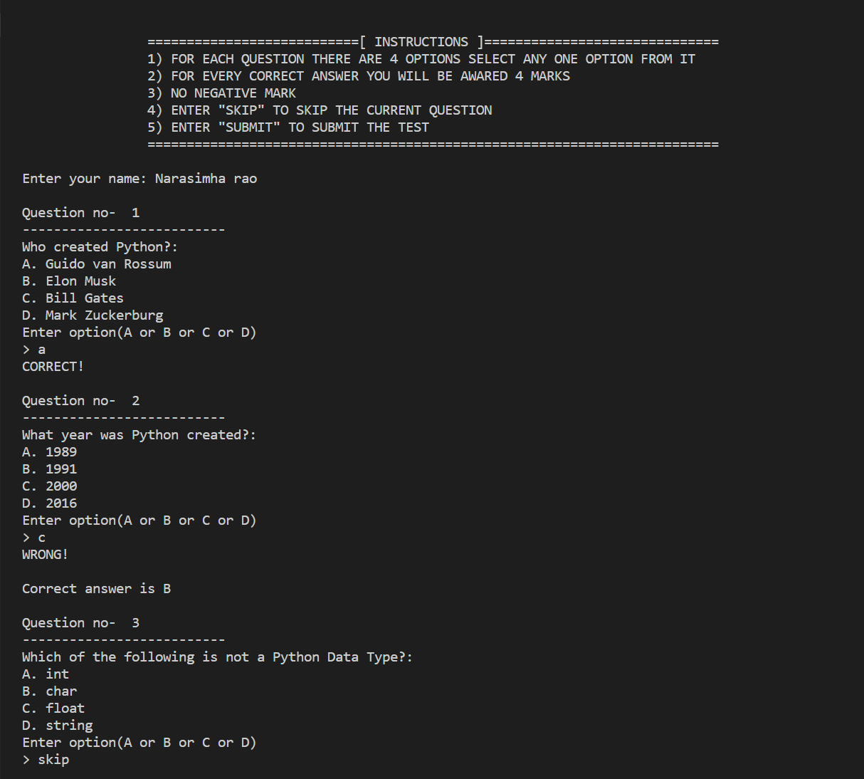

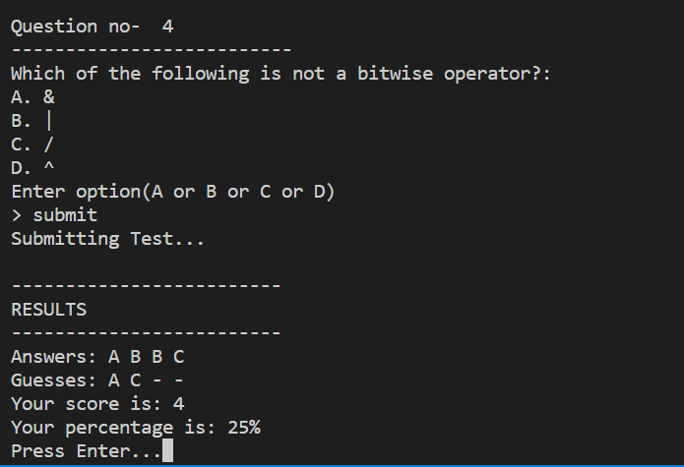

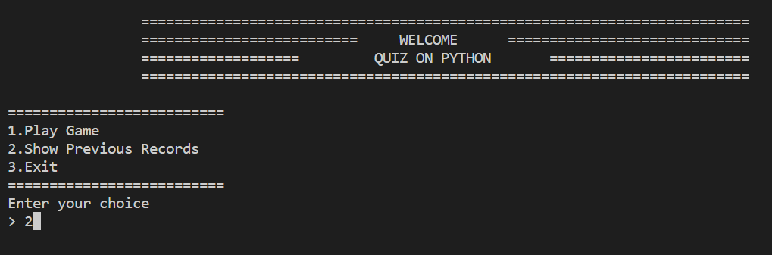

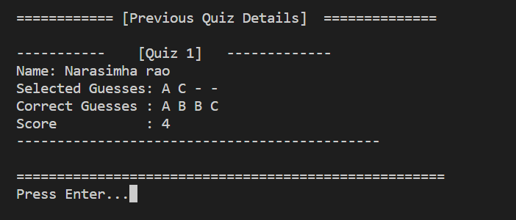

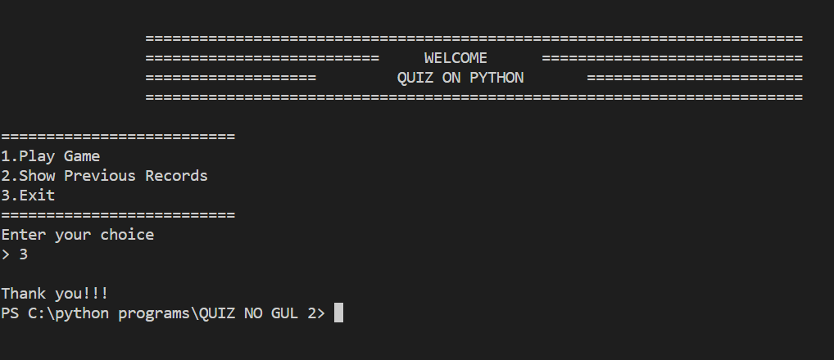

**4. Conclusion:**

In this process of making this project, we have understood the concepts of python and how to implement them. We created a user-friendly Quiz Game which gives both knowledge and entertainment.